Scrum Master Backend Report: Sprint 4 (September 11th – 15th)

Scrum Master: Maki

Participants: Charles, Ciar, Gray, Jethro, Pyper

# Meeting Notes for Planning:

* Meeting Date: 11/09/2023
* Sprint goals
  + Finish coding authentication/authorisation functionality (using Auth0 as the auth provider).
  + Carry out testing of the various functional requirements.
  + On Friday 15th September, submit the Team (Project) and Individual (Reflective Journal with Technical Commentary) components, along with Evaluation Forms (Team-, Peer-, Self-evaluation forms).
* Breakdown of tasks by team member
  + Authentication and authorisation (Jethro)
  + Carry out functional testing and report results in Testing Document:
    - Ciar: Auth0
    - Jethro: Article Creation
    - Pyper: Article Reading and Deletion
    - Gray: Article Updates
    - Maki: Filtering by Category
    - Charles: Keyword Search

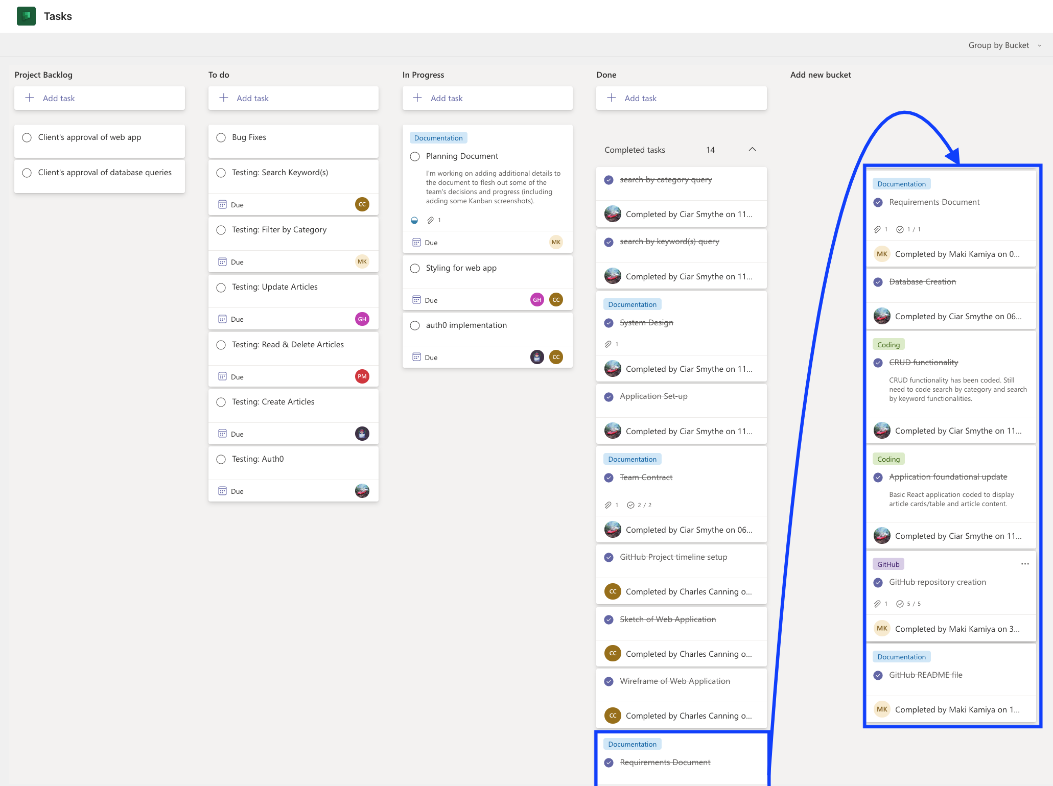

# Progress Updates throughout the Sprint:

# Retrospective Notes:

* Date: 15/09/2023
* Participants: Charles, Ciar, Gray, Jethro, Pyper, Maki

In this final iteration, our team has been focused on several tasks:

- Completing the authentication/authorisation implementation (Jethro).

- Wrapping up the CSS styling for the application (Charles).

- Testing functional requirements (all members).

Additionally, we have all been working to fulfil the documentation requirements for both our team and individual project submissions.

During today's meeting, we reviewed the progress of this last iteration and discussed the project's status as of today. We pinpointed areas that need final steps to be performed before submitting the project. This meeting marks our last official gathering as a project team.

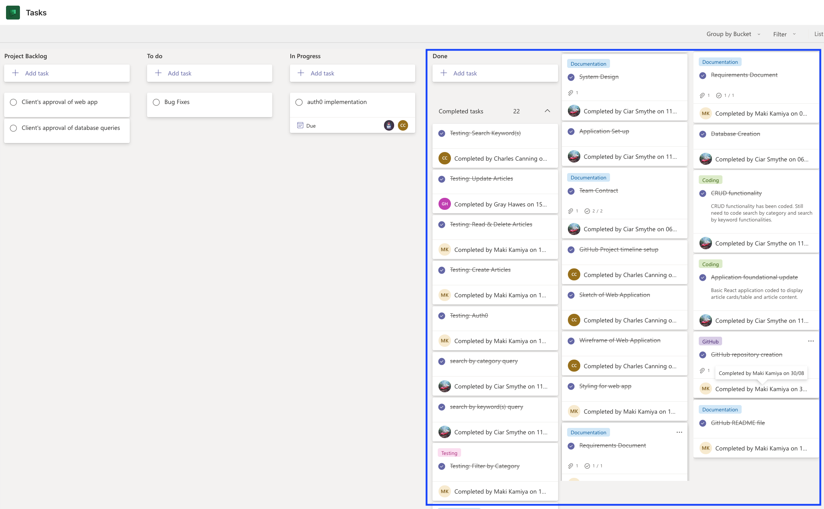

## Accomplished:

* CSS styling has been completed.
* Testing of functional requirements has been conducted and results recorded in the Testing Document.
* The final pull requests have been submitted and feature branches merged into the repo’s ‘main’ (default) branch.

## Not accomplished:

* Implementing authentication/authorisation using Auth0 was unable to be completed before project submission. This was due to our unfamiliarity with Auth0.

## What went well?

* Every team member worked hard to advance the project towards completion to meet our submission deadline. Their efforts were particularly effective due to the clear task allocation from the outset. This clear division of responsibilities meant everyone knew exactly what was expected of them, reducing overlap and confusion.